COMMERCIAL PACE MARKET ASSESSMENT TOOL User Guide

Table of Contents

Background 3

User Inputs 4

Interpreting the Results 7

Organization 7

Section 2.0: Building Characteristics Summary 8

Section 3.0: Energy Use Analysis 9

Section 4.0: Energy Savings Potential Analysis 11

Conclusion 14

Background

The purpose of the Commercial PACE Market Assessment Tool is to provide state and local jurisdictions with relevant data, estimations, and analyses to inform commercial property assessed clean energy (C-PACE) program creation, planning, and implementation. The tool is a product of the U.S. Department of Energy's (DOE) Commercial PACE Working Group and reflects input from Working Group participants.[1]

The tool generates a user-defined market assessment report of a specific city, county, or state's commercial energy consumption and savings potential broken down by building use type and end use. The tool is based on a methodology developed by Pacific Northwest National Laboratory (PNNL) using data from DOE's Commercial Building Inventories (dated 2019)[2], which is estimated primarily from CoStar Realty Information, Inc. (www.costar.com) building stock data, and the 2012 Commercial Building Energy Consumption Survey (CBECS).[3]

The tool can generate results for any state, any county with more than 20 buildings, and any city with more than 1,000 commercial buildings.

The information provided by this market assessment report does not predict the cost or energy savings of a specific C-PACE program, the level of C-PACE program uptake that might occur in the jurisdiction, or the suitability of C-PACE financing for a particular building. Rather, this report identifies jurisdiction-specific energy end uses, building use types, and building technologies that a decision maker can consider to justify joining or creating a C-PACE program and to more effectively allocate limited resources (e.g., marketing and partnership resources) to maximize energy savings and investment. The information presented in this report should be interpreted in the context of important local considerations (e.g., C-PACE program boundaries, development trends, property value trends, commercial benchmarking ordinances).

Use this Tool to:

1. Gain a more complete understanding of the market that could be served by a C-PACE program (e.g., number, types of buildings) and the opportunity available (e.g., energy and cost savings)
2. Accelerate uptake of C-PACE financing by targeting marketing, training, and resources towards high-potential market segments identified by the tool.

HOW THE tool can inform decisions

This report may be used to inform C-PACE program decisions related to goal setting, allocation of resources (e.g., what building types hold the greatest energy savings potential), and partnership building with property owners or contractors (e.g., what types of contractors install the technologies with the highest energy savings potential).

The Commercial PACE Market Assessment Tool is an Excel-based tool available for download. The file size is approximately 50 MB in size. For optimal readability, download the version compatible with your operating system:

* PC Version [INSERT LINK]
* Mac (iOS) Version [INSERT LINK]

User Inputs

This guide uses the city of Washington, D.C. as an example jurisdiction.

1. 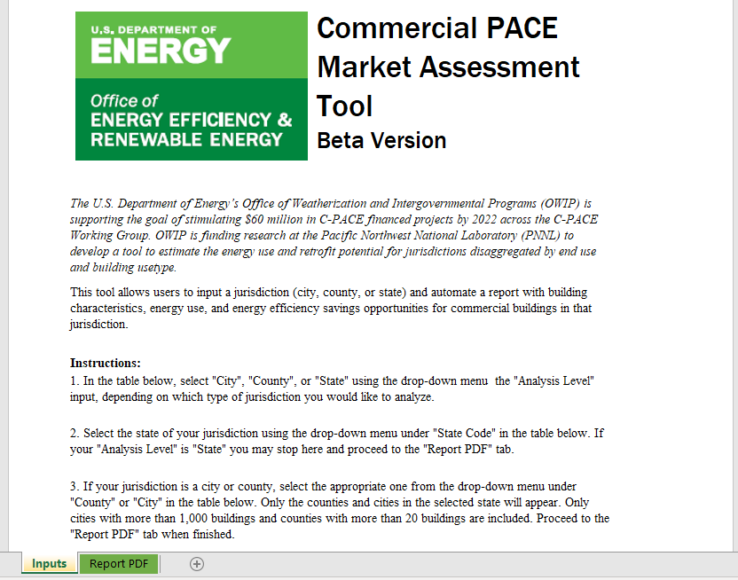Navigate to the “Inputs” tab in the spreadsheet.
2. 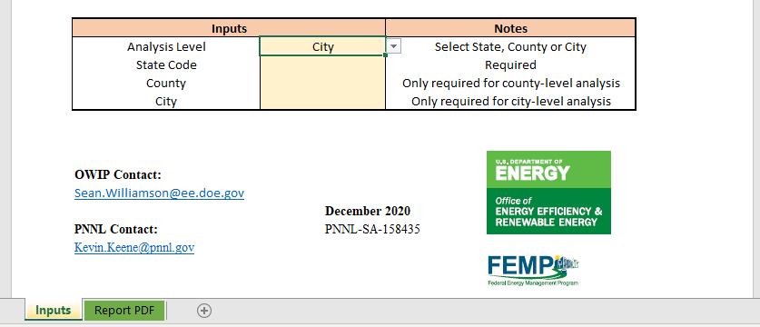Determine if you are conducting a city-level, county-level, or state-level analysis. In the highlighted cell next to “Analysis Level”, enter the appropriate choice using the drop-down menu.
3. 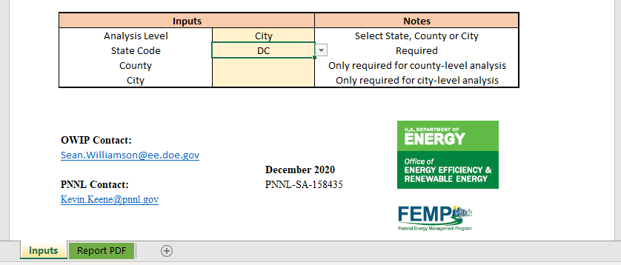Select the state that corresponds with your analysis using the drop-down menu in the highlighted cell next to “State Code”.
4. If conducting a state-level analysis, skip to step 5. If conducting a county-level analysis, select the name of the county using the drop-down menu in the highlighted cell next to “County”. If conducting a city-level analysis, select the name of the city using the drop-down menu in the highlighted cell next to “City”.

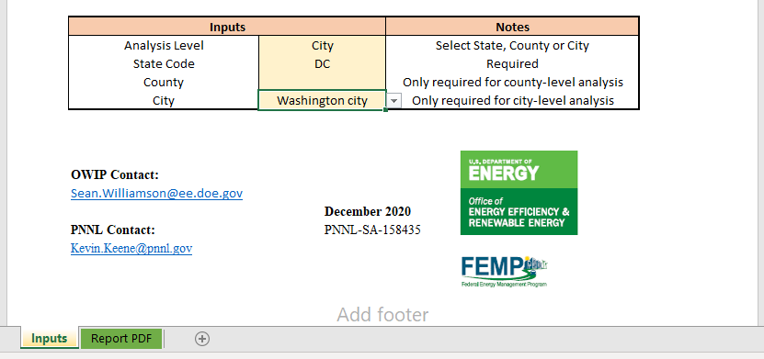*Note that only counties with more than 20 buildings and cities with more than 1,000 buildings are included in the drop-down table for each state.*

1. 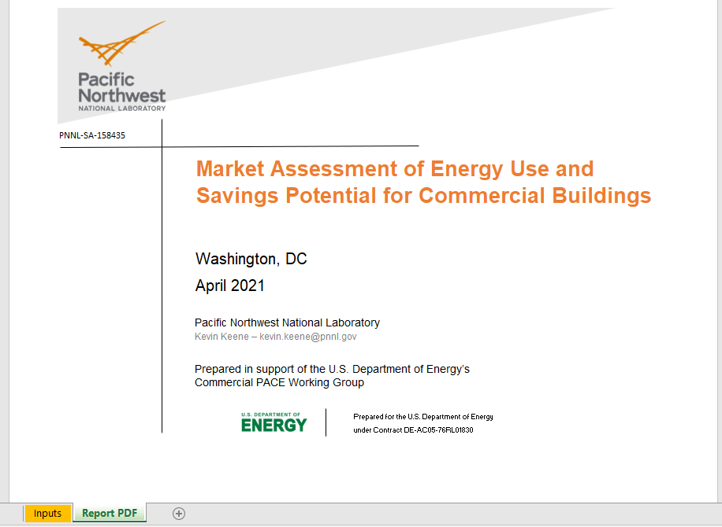Proceed to the “Report PDF” tab to see the results of your customized analysis.
2. 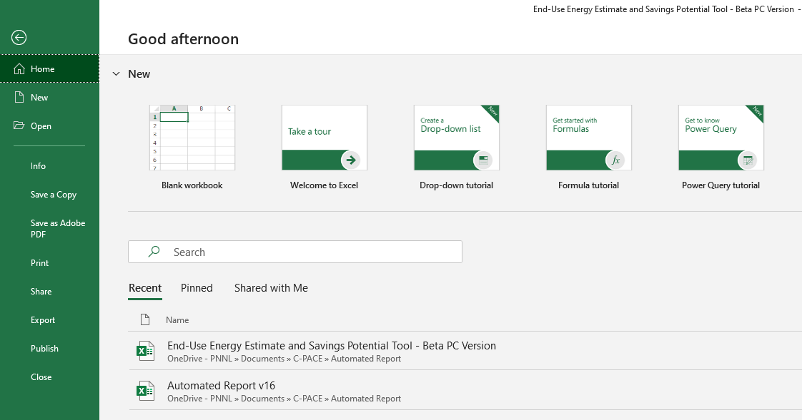To produce a PDF report of your jurisdiction, go to File > Save as Adobe PDF.

Interpreting the Results

The contents of the Market Assessment of Energy Use and Savings Potential for Commercial Buildings, or report, are automatically updated based on the user inputs. The user must first complete the “Inputs” tab before the report can be created.

Organization

The report is organized into four main sections, in addition to an executive summary and appendix:

* **Executive Summary**
  + Highlights actionable takeaways and key metrics from the report including building count, building use types, energy consumption among use types, and the use types with the largest potential for energy savings. Supporting tables and graphs are provided as well.

1. **Introduction**
   * Elaborates on the background of the report, the report structure, and important methodological considerations and limitations.
2. **Building Characteristics Summary**
   * Summarizes the building stock data corresponding with the user’s selected jurisdiction. Included are summary statistics of building size, count, vintage (age), occupancy type, and ownership type for each building use type.
3. **Energy Use Analysis**
   * Details the energy estimate (e.g., energy use intensity, energy consumption) for each building use type and energy end use.
4. **Retrofit Cost and Savings**
   * Estimates the energy savings potential for various retrofit technologies (e.g., wall insulation, heat pump system) for each building use type within the user-defined jurisdiction. The analysis is based on a data-driven prediction model using energy simulation results. The section is divided into two parts: Section 4.1 includes the results for buildings with lifetime energy savings greater than the estimated retrofit cost, or a savings-to-investment ratio greater than one. Section 4.2 includes all buildings regardless of the estimated retrofit cost

* **Appendix: Use Type Mapping**
  + Shows how the building use types are mapped between the datasets. The appendix gives users an understanding of what types of buildings are included in the different datasets used.

Section 2.0: Building Characteristics Summary

This section summarizes the building stock data used in the analysis. The building stock data used in this analysis includes most commercial buildings in the U.S. but does not include every building. Therefore, the building count and size in this section may be smaller than expected, depending on the jurisdiction.

Table 1 displays the percentage of buildings in each use type less than 10,000 square feet and greater than 10,000 square feet. Ten thousand square feet is a threshold building size below which potential energy savings are often lower, resulting in a potentially weaker business case for C-PACE financing. In this example, approximately 95% of multifamily space and office space is over 10,000 square feet.

|  |  |  |  |  |  |  |
| --- | --- | --- | --- | --- | --- | --- |
| **Table 1. Building size and count information by building use type** | | | | | |  |
| **Use Type** | | | **Floor Area** | | | **Building Count** |
| **< 10,000** | **> 10,000** | **Total (sq.ft.)** |
| Education | |  | 1.5% | 98.5% | 8,540,000 | 123 |
| Enclosed Mall | |  | 0.0% | 100.0% | 146,700 | 1 |
| Food Sales | |  | 14.5% | 85.5% | 861,200 | 76 |
| Food Service | |  | 78.1% | 21.9% | 1,135,100 | 276 |
| Inpatient Healthcare |  |  | 0.1% | 99.9% | 11,005,400 | 28 |
| Laboratory | |  | 1.7% | 98.3% | 444,000 | 3 |
| Lodging | |  | 0.6% | 99.4% | 34,040,600 | 252 |
| Multifamily | |  | 6.1% | 93.9% | 235,131,400 | 5,540 |
| Nonrefrigerated Warehouse | | | 9.1% | 90.9% | 9,943,400 | 381 |
| Nursing | |  | 2.2% | 97.8% | 2,764,600 | 38 |
| Office |  |  | 4.5% | 95.5% | 182,142,600 | 3,540 |
| Other |  |  | 5.0% | 95.0% | 7,649,200 | 176 |
| Outpatient Healthcare | | | 5.1% | 94.9% | 3,353,200 | 75 |
| Public Assembly | |  | 6.6% | 93.4% | 4,661,300 | 122 |
| Public Order and Safety | | | 10.7% | 89.3% | 596,500 | 18 |
| Refrigerated Warehouse | | | 20.7% | 79.3% | 40,600 | 2 |
| Religious Worship | |  | 28.9% | 71.1% | 3,884,200 | 362 |
| Retail |  |  | 30.6% | 69.4% | 15,366,300 | 1,824 |
| Service | |  | 49.5% | 50.5% | 1,175,500 | 229 |
| **All Buildings** | |  | **6.1%** | **93.9%** | **522,881,800** | **13,066** |

Table 2 shows the distribution of building floor area within vintage, or age ranges. Some use types, such as inpatient healthcare and education, are more likely to have properties with no age reported. The data does not reflect buildings that have received upgrades since construction. However, the age of building use types can be an indicator as to which building use types have high retrofit potential due to aging equipment.

|  |  |  |  |  |  |  |  |  |  |  |
| --- | --- | --- | --- | --- | --- | --- | --- | --- | --- | --- |
| **Table 2. Building vintage distribution by building use type** | | | | | | | | | | |
| **Use Type** | | | **Before 1940** | **1940 - 1960** | **1960 - 1980** | **1980 - 2000** | **2000 - 2017** | **After 2017** | **No Age Reported** | **Average Vintage** |
| Education | |  | 4% | 5% | 23% | 21% | 17% | 8% | 23% | 1979.0 |
| Enclosed Mall | |  | 0% | 0% | 14% | 38% | 39% | 6% | 3% | 1996.2 |
| Food Sales |  |  | 0% | 3% | 10% | 40% | 45% | 1% | 1% | 1984.9 |
| Food Service | |  | 5% | 12% | 22% | 31% | 24% | 4% | 4% | 1982.0 |
| Inpatient Healthcare | |  | 0% | 6% | 13% | 38% | 25% | 5% | 13% | 1997.8 |
| Laboratory | |  | 1% | 1% | 10% | 69% | 15% | 4% | 0% | 1988.8 |
| Lodging | |  | 7% | 2% | 13% | 36% | 28% | 8% | 6% | 1987.5 |
| Multifamily | |  | 3% | 1% | 19% | 30% | 30% | 14% | 3% | 1979.8 |
| Nonrefrigerated Warehouse | | | 2% | 7% | 26% | 34% | 21% | 8% | 4% | 1982.9 |
| Nursing | |  | 0% | 0% | 11% | 34% | 42% | 10% | 3% | 1995.2 |
| Office |  |  | 7% | 3% | 19% | 39% | 18% | 7% | 6% | 1977.7 |
| Other |  |  | 2% | 5% | 21% | 32% | 16% | 9% | 15% | 1979.8 |
| Outpatient Healthcare | | | 3% | 2% | 19% | 31% | 32% | 11% | 2% | 1990.6 |
| Public Assembly | |  | 3% | 3% | 9% | 28% | 17% | 3% | 38% | 1980.1 |
| Public Order and Safety | | | 4% | 12% | 76% | 0% | 0% | 0% | 8% | 1950.0 |
| Refrigerated Warehouse | | | 0% | 0% | 14% | 66% | 0% | 21% | 0% | 1990.0 |
| Religious Worship | |  | 1% | 5% | 25% | 21% | 3% | 2% | 43% | 1976.0 |
| Retail |  |  | 2% | 6% | 22% | 34% | 25% | 5% | 5% | 1978.8 |
| Service | |  | 3% | 10% | 38% | 32% | 9% | 2% | 6% | 1977.9 |
| **All Buildings** | |  | **4%** | **5%** | **21%** | **35%** | **23%** | **7%** | **5%** | **1980.6** |

Table 3 and Table 4 show the distribution of buildings between occupancy types (e.g., leased, owner occupied) and ownership type (e.g., government, private), respectively. Note that the information presented in these tables, unlike the previous tables, is averaged at the census division level,[4] which is the most granular geographic information provided by the data source (i.e., CBECS). There may be variation between the census division level and jurisdiction level. This information can be used to inform C-PACE program structure and allocation of marketing and engagement resources to different ownership types. For example, in the table below, 67% of retail properties are leased to a tenant, which means depending on the lease structure, both the tenant and the owner may need to be engaged as part of C-PACE marketing efforts.

IMPORTANT CONSIDERATION

This analysis relies on a large sample of buildings to provide accurate results. Look at the number of buildings included for each use type when interpreting the results. Use types with fewer than 30 buildings will have a higher degree of uncertainty.

|  |  |  |  |  |  |  |  |  |  |  |
| --- | --- | --- | --- | --- | --- | --- | --- | --- | --- | --- |
| **Table 3. Occupancy type distribution by building use type** | | | | | | | | | | |
| **Use Type** | | | **Combination Occupied and Leased** | | **Leased to Tenant** | | **Owner Occupied** | | **Not Applicable** | |
| Education | |  |  | 3% |  | 4% |  | 93% |  | 0% |
| Enclosed Mall | |  |  | 85% |  | 15% |  | 0% |  | 0% |
| Food Sales |  |  |  | 10% |  | 52% |  | 38% |  | 0% |
| Food Service | |  |  | 2% |  | 36% |  | 62% |  | 0% |
| Inpatient Healthcare | |  |  | 18% |  | 2% |  | 80% |  | 0% |
| Laboratory | |  |  | 4% |  | 15% |  | 81% |  | 0% |
| Lodging | |  |  | 5% |  | 31% |  | 65% |  | 0% |
| Multifamily | |  |  | 0% |  | 75% |  | 21% |  | 3% |
| Nonrefrigerated Warehouse | | |  | 11% |  | 57% |  | 32% |  | 0% |
| Nursing | |  |  | 3% |  | 18% |  | 79% |  | 0% |
| Office |  |  |  | 23% |  | 40% |  | 37% |  | 0% |
| Other |  |  |  | 12% |  | 5% |  | 83% |  | 0% |
| Outpatient Healthcare | | |  | 33% |  | 40% |  | 27% |  | 0% |
| Public Assembly | |  |  | 20% |  | 15% |  | 65% |  | 0% |
| Public Order and Safety | | |  | 10% |  | 18% |  | 72% |  | 0% |
| Refrigerated Warehouse | | |  | 34% |  | 16% |  | 49% |  | 0% |
| Religious Worship | |  |  | 11% |  | 4% |  | 85% |  | 0% |
| Retail |  |  |  | 10% |  | 67% |  | 23% |  | 0% |
| Service | |  |  | 10% |  | 51% |  | 39% |  | 0% |
| **All Buildings** | |  |  | **13%** |  | **34%** |  | **51%** |  | **2%** |

Section 3.0: Energy Use Analysis

This section excludes the following building use types that are included in Section 2.0:

* Multi-family
* Laboratory
* Enclosed mall
* Public assembly and safety
* Other[5]

These use types are excluded because they are not applicable for C-PACE programs (e.g., public facilities), have limited sample size in most jurisdictions, or lack suitable data to estimate the energy use (e.g., multi-family buildings).

There are two important considerations for this section before interpreting the results:

1. **Sample Size:** The analysis used in this report relies on aggregated results (i.e., does not accurately predict the energy use of individual or small numbers of buildings, but gives more accurate results for large sample sizes). Consider the total number of buildings and number of buildings in each use type when using the results (see Table 1 or Table 5). Use types with fewer buildings within a jurisdiction (e.g., use types with fewer than 30 buildings) will yield less accurate results. Use types with few buildings may not be desired as the focus of C-PACE program marketing efforts.
2. **Local variations:** This analysis estimates local energy use with regional energy data applied to local building stock data. The accuracy of the results of this analysis depends on how closely the local portfolio aligns with regional energy use. For example, if local buildings are very efficient compared to the region due to investment in local energy efficiency programs, incentives, and education, this will likely result in an overestimate of actual energy use and energy savings potential.

Table 5 shows the estimated energy consumption by use type. The results are presented in building size ranges (i.e., under 10,000 square feet, or sq.ft.; 10,000-50,000 sq.ft.; and over 50,000 sq.ft.) as one way to segment the market by small, medium, and large buildings. Note the units of energy consumption in the table heading (e.g., GBtu/year, or giga British thermal units in the example below). The units will change depending on the size of the values in the table to accommodate different sized jurisdictions. In the figure below, office buildings consume the most energy overall (11,312 GBtu/year), which is concentrated in buildings greater than 50,000 square feet. This estimate is based on 3,430 buildings (much greater than 30), meaning the calculation is based on a reliable sample size.

|  |  |  |  |  |  |  |  |  |  |  |
| --- | --- | --- | --- | --- | --- | --- | --- | --- | --- | --- |
| **Table 5. Energy consumption in GBtu/year and building count by floor area range** | | | | | | | | | | |
| **Use Type** | | | **< 10,000 sq.ft** | | **10,000 – 50,000 sq.ft.** | | **> 50,000 sq.ft.** | | **All Buildings** | |
| **Energy Use** | **No. of Bldg.** | **Energy Use** | **No. of Bldg.** | **Energy Use** | **No. of Bldg.** | **Energy Use** | **No. of Bldg.** |
| Education | |  | 10 | 27 | 88 | 46 | 485 | 50 | 583 | 123 |
| Food Sales | |  | 26 | 59 | 30 | 9 | 80 | 8 | 135 | 76 |
| Food Service | |  | 225 | 258 | 49 | 18 | - | - | 274 | 276 |
| Lodging | |  | 15 | 37 | 143 | 62 | 2,875 | 153 | 3,033 | 252 |
| Nonrefrigerated Warehouse | | | 42 | 165 | 175 | 169 | 213 | 47 | 429 | 381 |
| Nursing | |  | 6 | 13 | 5 | 4 | 273 | 21 | 284 | 38 |
| Office |  |  | 597 | 2,326 | 822 | 542 | 12,240 | 672 | 13,659 | 3,540 |
| Outpatient Healthcare | | | 15 | 39 | 50 | 18 | 286 | 18 | 351 | 75 |
| Refrigerated Warehouse | | | 1 | 1 | 3 | 1 | - | - | 4 | 2 |
| Religious Worship | |  | 55 | 246 | 108 | 112 | 27 | 4 | 190 | 362 |
| Retail |  |  | 408 | 1,646 | 232 | 139 | 787 | 39 | 1,427 | 1,824 |
| Service | |  | 48 | 203 | 24 | 23 | 14 | 3 | 86 | 229 |
| **All Buildings** | |  | 1,447 | 5,020 | 1,724 | 1,143 | 17,280 | 1,015 | 20,450 | 7,178 |

Understanding energy consumption for each use type is an important consideration for the scale of savings potential in each use type and end use but does not necessarily guarantee a large savings potential. Table 6 and Figure 1 show the energy use intensity in kBtu/square foot/year for each use type and for each energy end use (e.g., heating, cooling). Office equipment, computing, and other end uses are combined into the "Misc." end use category. In this example, food service has the highest energy intensity and religious worship has the lowest. Note that food sales and food service frequently have high EUIs. However, C-PACE financing may not be the most suitable tool for addressing these use types because C-PACE financing cannot be used to replace non-affixed building equipment (e.g., stoves, ovens, refrigerators). C-PACE programs finance equipment 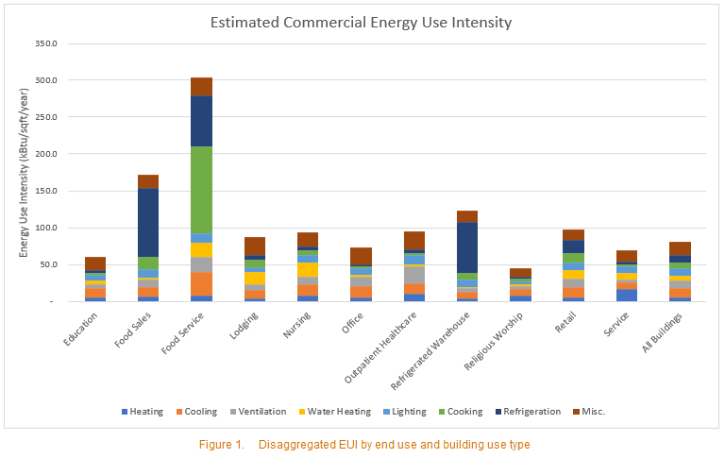affixed to a property.

Section 4.0: Energy Savings Potential Analysis

This section details the energy savings potential for various retrofit technologies (e.g., wall insulation, heat pump system) for each building use type. The analysis is based on a data-driven prediction model using energy simulation results. This section excludes the following use types:

* Multi-family
* Laboratory
* Enclosed mall
* Public assembly and safety
* Other

The following retrofit options are included:

* Wall insulation
* Roof insulation
* Window upgrade
* Rooftop heat pump
* High-efficiency chiller
* Electric boiler
* Packaged rooftop unit
* Hot water heat pump
* LED integrated luminaires
* Combined retrofit (Rooftop heat pump + hot water heat pump + LED luminaires)

The energy efficiency information, capital cost, and useful life span for each of these retrofits is sourced from DOE’s Scout Tool.[6] The business-as-usual typical replacement cost at the end of the remaining life of the existing equipment is sourced from the National Building Construction Manual.[7]

This section is divided into two sub-sections: sub-section 4.1 includes the results for buildings with lifetime energy savings greater than the estimated retrofit cost, or a savings-to-investment ratio greater than one (SIR>1). This sub-section is useful for identifying which technologies and use types stand to see the greatest return on investment, which generally excludes high efficiency buildings with less potential to cost-effectively retrofit. Sub-section 4.2 includes all buildings regardless of the estimated retrofit cost and cost effectiveness. This sub-section is useful for comparing technologies and use types independent of the investment cost. Construction costs are difficult to predict and less accurate, so sub-section 4.2 may be preferred for users that can provide their own retrofit cost estimates or do not need to consider retrofit costs.

There are a few important considerations for interpreting the results in this section:

1. **Sample Size:** The analysis used in this report relies on aggregated results (i.e., does not accurately predict the results of individual or small numbers of buildings but gives more accurate results for large sample sizes). In sub-section 4.1, if a building cannot be cost-effectively retrofitted with a technology (i.e., the capital costs exceed the lifetime energy savings), then the building is not included in the analysis. The results in sub-section 4.1 are based on fewer buildings compared to other sections and sub-section 4.2. Use types with fewer buildings within a jurisdiction (e.g., fewer than 30 buildings) are less accurate than use types with more buildings.

IMPORTANT CONSIDERATION

This report does not predict the actual cost or energy savings of a specific C-PACE program, the level of C-PACE program uptake that might occur in the jurisdiction, or the suitability of C-PACE financing for a particular building. Use this tool to assess the overall market opportunity available for C-PACE financing in a given jurisdiction.

1. **Retrofit cost information**: This data plays a central role for the financial cost-benefit analysis but is notably difficult to predict and subject to regional variations in labor and equipment, and volatility in material prices, which adds uncertainty to the results.
2. **Local variations:** This analysis estimates energy savings with regional energy data applied to local building stock data. The accuracy of the results of this analysis depends on how closely the local energy use compares to regional energy use. For example, if the local buildings are very efficient compared to the region due to past investment in local energy efficiency programs, incentives, and education, this will likely cause this analysis to overestimate the energy savings potential.
3. **Real-life applicability:** Most importantly, this report does not predict the actual cost or energy savings of a specific C-PACE program, the level of C-PACE program uptake that might occur in the jurisdiction, or the suitability of C-PACE financing for a particular building. Rather, the estimates provided in the report represent an energy and cost savings opportunity a C-PACE program can address.

Table 7 and Table 8 (not included in example below), respectively, show the number of buildings and total building floor area that are cost-effective for a given the retrofit with a threshold requirement that lifetime energy savings must be equal to or greater than capital costs (i.e., SIR>1).

|  |  |  |  |  |  |  |  |  |  |  |  |
| --- | --- | --- | --- | --- | --- | --- | --- | --- | --- | --- | --- |
| **Table 7. Number of buildings by retrofit technology and use type, only retrofits with SIR>1** | | | | | | | | | | | |
| **Use Type** | | **Wall Insulation** | **Roof Insulation** | **Window Upgrade** | **Rooftop Heat Pump** | **Chiller** | **Boiler** | **Packaged Rooftop Unit** | **Hot Water Heat Pump** | **LED Lighting** | **Combined Retrofit** |
| Education | | 0 | 27 | 2 | 10 | 181 | 0 | 1 | 189 | 186 | 90 |
| Food Sales | | 0 | 367 | 2 | 423 | 516 | 0 | 441 | 232 | 516 | 516 |
| Food Service | | 0 | 1,109 | 3 | 966 | 1,677 | 0 | 1,269 | 1,677 | 1,677 | 1,674 |
| Lodging | | 0 | 0 | 21 | 130 | 401 | 0 | 48 | 401 | 398 | 401 |
| Nonrefrigerated Warehouse | | 0 | 415 | 12 | 2,169 | 2,169 | 0 | 2,169 | 1,764 | 2,140 | 2,169 |
|  |  |  |  |  |  |  |  |  |  |
| Nursing |  | 2 | 0 | 13 | 99 | 99 | 0 | 99 | 99 | 99 | 99 |
| Office |  | 2 | 509 | 39 | 2,171 | 2,874 | 1,405 | 1,816 | 1,193 | 2,874 | 2,874 |
| Outpatient Healthcare | | 0 | 32 | 7 | 1 | 791 | 110 | 1 | 458 | 791 | 728 |
|  |  |  |  |  |  |  |  |  |  |
| Refrigerated Warehouse | | 0 | 0 | 6 | 6 | 6 | 0 | 6 | 5 | 6 | 6 |
|  |  |  |  |  |  |  |  |  |  |
| Religious Worship | | 0 | 0 | 0 | 1 | 95 | 0 | 0 | 22 | 7 | 5 |
| Retail |  | 0 | 2,656 | 13 | 839 | 5,364 | 10 | 3,288 | 5,364 | 5,364 | 5,364 |
| Service | | 0 | 872 | 1 | 917 | 1,565 | 7 | 160 | 1,567 | 1,567 | 1,567 |
| **All Buildings** | | **7** | **5,987** | **119** | **7,732** | **15,738** | **1,532** | **9,298** | **12,971** | **15,625** | **15,493** |

Table 9 shows the gross dollar savings, Table 10 net savings (i.e., gross savings minus capital cost; not included in the example below), and Table 11 (not included in the example below) energy savings for each use type and retrofit option. The energy savings are converted to monetary values based on the local (county-level) cost of energy estimated in DOE’s City and County Energy Profiles.[8] Note the units in the table heading change based on the scale of the results. The table below shows that offices are a use type with a high magnitude of potential savings on the order of hundreds of millions of dollars in energy savings across the lifespan of the equipment. Chillers and LED lighting are the two highest retrofit technologies across all use types, saving a potential $585M and $769M, respectively.

|  |  |  |  |  |  |  |  |  |  |  |  |
| --- | --- | --- | --- | --- | --- | --- | --- | --- | --- | --- | --- |
| **Table 9. Gross savings (thousand $USD) potential by retrofit technology and use type, only retrofits with SIR>1** | | | | | | | | | | | |
| **Use Type** | | **Wall Insulation** | **Roof Insulation** | **Window Upgrade** | **Rooftop Heat Pump** | **Chiller** | **Boiler** | **Packaged Rooftop Unit** | **Hot Water Heat Pump** | **LED Lighting** | **Combined Retrofit** |
| Education | | $0 | $0 | $0 | $0 | $5 | $0 | $0 | $1 | $6 | $5 |
| Food Sales | | $0 | $0 | $0 | $3 | $10 | $0 | $11 | $0 | $19 | $33 |
| Food Service | | $0 | $2 | $0 | $18 | $41 | $0 | $28 | $10 | $30 | $80 |
| Lodging | | $0 | $0 | $7 | $11 | $63 | $0 | $2 | $34 | $87 | $195 |
| Nonrefrigerated Warehouse | | $0 | $1 | $2 | $61 | $55 | $0 | $56 | $11 | $225 | $307 |
|  |  |  |  |  |  |  |  |  |  |
| Nursing | | $1 | $0 | $2 | $18 | $19 | $0 | $16 | $8 | $23 | $57 |
| Office |  | $4 | $0 | $16 | $61 | $174 | $3 | $41 | $3 | $239 | $435 |
| Outpatient Healthcare | | $0 | $0 | $1 | $0 | $32 | $1 | $0 | $2 | $66 | $101 |
|  |  |  |  |  |  |  |  |  |  |
| Refrigerated Warehouse | | $0 | $0 | $0 | $1 | $1 | $0 | $1 | $0 | $5 | $7 |
|  |  |  |  |  |  |  |  |  |  |
| Religious Worship | | $0 | $0 | $0 | $0 | $2 | $0 | $0 | $0 | $0 | $0 |
| Retail |  | $0 | $4 | $5 | $11 | $209 | $0 | $124 | $68 | $311 | $604 |
| Service | | $0 | $1 | $0 | $11 | $16 | $0 | $2 | $5 | $30 | $66 |
| **All Buildings** |  | **$5** | **$8** | **$33** | **$194** | **$627** | **$4** | **$281** | **$143** | **$1,042** | **$1,889** |

Table 12 shows the gross savings and Table 13 (not included in the example below) shows the energy savings for each use type and retrofit if all buildings are considered no matter the retrofit cost. Note the units in the table heading change based on the scale of the results. A table presenting the net savings for retrofits regardless of cost is deliberately excluded from the report because this analysis includes many newer, high-performing buildings with lower energy saving potential, which results in negative net cost savings, or costs exceeding lifetime energy savings. In this example, office buildings show the greatest energy savings potential, followed by lodging and retail. LED lighting, rooftop heat pumps, wall insulation, and chillers show the greatest energy savings potential.

|  |  |  |  |  |  |  |  |  |  |  |
| --- | --- | --- | --- | --- | --- | --- | --- | --- | --- | --- |
| **Table 12. Lifetime gross savings (million $USD) potential by retrofit technology and use type, regardless of SIR** | | | | | | | | | | |
| **Use Type** | **Wall Insulation** | **Roof Insulation** | **Window Upgrade** | **Rooftop Heat Pump** | **Chiller** | **Boiler** | **Packaged Rooftop Unit** | **Hot Water Heat Pump** | **LED Lighting** | **Combined Retrofit** |
| Education | $1 | $1 | $1 | $5 | $5 | $0 | $4 | $1 | $6 | $13 |
| Food Sales | $3 | $1 | $2 | $11 | $10 | $1 | $13 | $1 | $19 | $33 |
| Food Service | $6 | $3 | $9 | $33 | $41 | $2 | $35 | $10 | $30 | $80 |
| Lodging | $10 | $6 | $14 | $55 | $63 | $2 | $41 | $34 | $87 | $195 |
| Nonrefrigerated Warehouse | $12 | $7 | $15 | $61 | $55 | $7 | $56 | $14 | $225 | $307 |
|  |  |  |  |  |  |  |  |  |  |
| Nursing | $5 | $2 | $4 | $18 | $19 | $1 | $16 | $8 | $23 | $57 |
| Office | $43 | $16 | $49 | $159 | $174 | $7 | $138 | $12 | $239 | $435 |
| Outpatient Healthcare | $6 | $3 | $6 | $33 | $32 | $3 | $23 | $3 | $66 | $102 |
|  |  |  |  |  |  |  |  |  |  |
| Refrigerated Warehouse | $0 | $0 | $0 | $1 | $1 | $0 | $1 | $0 | $5 | $7 |
|  |  |  |  |  |  |  |  |  |  |
| Religious Worship | $0 | $0 | $0 | $2 | $2 | $0 | $2 | $0 | $2 | $5 |
| Retail | $40 | $17 | $47 | $176 | $209 | $12 | $193 | $68 | $311 | $604 |
| Service | $3 | $3 | $4 | $24 | $16 | $2 | $18 | $5 | $30 | $66 |
| **All Buildings** | **$130** | **$58** | **$154** | **$577** | **$628** | **$37** | **$540** | **$156** | **$1,045** | **$1,903** |

Conclusion

The Commercial PACE Market Assessment Tool produces actionable information for states and local governments evaluating, creating, joining, or implementing a C-PACE program. The magnitude of information generated by the report can be difficult to sort through and interpret, and all of the information may not be relevant for every jurisdiction. The Executive Summary is available as a high-level summary of commercial building stock attributes and includes actionable takeaways. More sophisticated users including program administrators or state and local energy professionals can go deeper with the tables presented in the full report. Users of the tool are encouraged to enhance the results of the tool with their own locally sourced information (e.g., benchmarking data) to make more informed decisions.

Additional Data Tools

There are numerous additional data tools developed by DOE and its national laboratories available to inform states and local governments with their commercial building energy goals, including:

* [State and Local Planning for Energy (SLOPE) Platform](https://gds.nrel.gov/slope) – SLOPE enables more data-driven state and local energy planning by integrating dozens of distinct sources of energy efficiency, renewable energy, and sustainable transportation data and analyses into an easy-to-access online platform.
* [ComStock Analysis Tool](https://www.nrel.gov/buildings/comstock.html) – ComStock allows stakeholders to better understand how the commercial building stock in the U.S. uses energy and how different technologies and demand-side management strategies could change that energy use pattern.
* [DOE’s Commercial Building Inventories](https://openei.org/doe-opendata/dataset/city-and-county-commercial-building-inventories) – The Commercial Building Inventories provide modeled data on commercial building type, vintage, and area for each U.S. city and county.
* [Building Energy Asset Score](https://www.energy.gov/eere/buildings/building-energy-asset-score) – Asset Score is a national standardized tool for assessing the physical and structural energy efficiency of commercial and multifamily residential buildings. The Asset Score generates a simple energy efficiency rating that enables comparison among buildings and identifies opportunities to invest in energy efficiency upgrades.
* [Scout](https://www.energy.gov/eere/buildings/scout) – Scout is a tool for estimating the energy and carbon impacts of various energy conservation measures (ECMs) on the U.S. residential and commercial building sectors.
* [Home Energy Score](https://www.energy.gov/eere/buildings/downloads/home-energy-score) – Home Energy Score provides homeowners, buyers, and renters directly comparable and credible information about a home’s energy use. Like a miles-per-gallon rating for a car, the Home Energy Score is based on a standard assessment of energy-related assets to easily compare energy use across the housing market.

Acknowledgements

This guide was prepared by Kevin Keene of PNNL under contract to the U.S. Department of Energy (DOE). The work was supported by DOE’s Office of Weatherization and Intergovernmental Programs led by Sean Williamson. The authors would like to thank Juan Gonzalez from PNNL for review and feedback in support of this document.

1. All participants in the C-PACE Working Group can be found online here: <https://www.energy.gov/eere/slsc/commercial-pace-working-group>.
2. <https://openei.org/doe-opendata/dataset/city-and-county-commercial-building-inventories>
3. <https://www.eia.gov/consumption/commercial/data/2012/index.php?view=microdata>
4. <https://www2.census.gov/geo/pdfs/maps-data/maps/reference/us_regdiv.pdf>
5. Other includes: Airplane Hangar, Airport, Auto Salvage Facility, Cement/Gravel Plant, Cemetery/Mausoleum, Chemical/Oil Refinery, Contractor Storage Yard, Flex, Food Processing, General Services, Industrial, Industrial Live/Work Unit, Landfill, Light Manufacturing, Lumberyard, Manufactured Housing/Mobile Home Park, Manufacturing, Marina, Movie/Radio/TV Studio, Parking Garage, Parking Lot, Radio/TV Transmission Facilities, Railroad Yard, Recycling Center, Residential Income, Shipyard, Specialty, Telecom Hotel/Data Hosting, Trailer / Camper Park, Truck Terminal, Unknown, Utility Sub-Station, Water Retention Facility, Water Treatment Facility, Wholesale Trade, and Winery/Vineyard.
6. <https://github.com/trynthink/scout/tree/master/ecm_definitions>
7. [https://www.craftsman-book.com/2020-national-building-cost-manual](https://gcc02.safelinks.protection.outlook.com/?url=https%3A%2F%2Fwww.craftsman-book.com%2F2020-national-building-cost-manual&data=04%7C01%7Ckevin.keene%40pnnl.gov%7C6d532c3c77494d12e2f808d8859e3fd4%7Cd6faa5f90ae240338c0130048a38deeb%7C0%7C0%7C637406262006933793%7CUnknown%7CTWFpbGZsb3d8eyJWIjoiMC4wLjAwMDAiLCJQIjoiV2luMzIiLCJBTiI6Ik1haWwiLCJXVCI6Mn0%3D%7C1000&sdata=4MUL5ksumEqJDbWEuzFAt5JNrR8wW6BSGLI2YMN0QAA%3D&reserved=0)
8. <https://openei.org/doe-opendata/dataset/city-county-energy-profiles>